Department of Computer Science and Engineering
Assignment Questions
Course Code & Name : CSA07- Computer Networks
Assignment Title: | Design and Performance Evaluation of a Smart Manufacturing Industrial Network
Course Outcome(s) – CO: | 1-Apply the functions of the OSI layer in enabling reliable data transmission across networks  2-Configure IP addressing schemes, subnetting, and basic routing techniques using a simulation tool, for efficient network design and topology  3-Analyze and compare the performance of core network protocols such as TCP, UDP, HTTP, and DNS under varying conditions  4-Design network topologies star, mesh, bus, and hybrid using networking devices, transmission media, and cabling standards  5-Measure network performance using key metrics with simulation tools
Bloom’s Taxonomy Level | L3 – Apply; L4 – Analyse, L5 – Evaluate
SDG Mapping (SDG 1-17) | SDG 11 – Sustainable Cities and Communities;  SDG 12 – Responsible Consumption and Production
Problem Statement : A manufacturing company is modernizing its production facility by connecting the Production Floor, Quality Inspection Unit, Warehouse, Administrative Office, IoT-enabled machines, and a Cloud Monitoring Centre. The existing network experiences communication delays, congestion during peak production hours, inefficient IP address allocation, and poor Quality of Service for time-sensitive applications such as machine monitoring, video surveillance, and real-time control.
As a network engineer, design and simulate a reliable industrial network that supports the above departments and devices. Select suitable network topologies, switches, routers, wireless devices, transmission media, and LAN/WAN connections. Divide the network into appropriate subnets/VLANs and develop an IPv4 addressing scheme. Implement and compare Distance Vector and Link State routing for inter-network communication using a suitable simulation tool. Demonstrate TCP and UDP communication and analyse their behaviour under different traffic conditions.
The network must provide congestion and traffic management with suitable QoS mechanisms so that critical industrial traffic receives higher priority than non-critical traffic. Configure appropriate application-layer services such as DNS, DHCP, HTTP/FTP and SNMP for network operation and monitoring. Incorporate IoT devices and cloud-based monitoring, and discuss SDN/network virtualization as an enhancement. Evaluate the proposed architecture using packet delivery ratio, throughput, end-to-end delay, packet loss and congestion, and recommend the most suitable network architecture for the company.
Industry-Based Tasks / Expected Analysis
1. Identify business and operational requirements and prepare a physical/logical network topology for the manufacturing facility.
2. Select network devices and transmission media and justify their suitability for industrial communication.
3. Create VLANs/subnets and an IPv4 addressing plan; demonstrate packet forwarding between the subnets.
4. Implement Distance Vector and Link State routing and compare routing behaviour and performance.
5. Configure TCP and UDP applications and analyse throughput, delay, packet loss and traffic/congestion behaviour.
6. Apply a suitable QoS/traffic-management strategy to prioritize time-sensitive machine-control and monitoring traffic.
7. Configure DNS, DHCP, HTTP/FTP and SNMP services and demonstrate their role in network operation and monitoring.
8. Add IoT/cloud-monitoring components and discuss how SDN or network virtualization can improve scalability and manageability.
9. Recommend the final network architecture based on measured simulation results and operational requirements.

Problem Challenge:
A retail organization plans to connect the following locations: Head Office (HO), Branch A, Branch B, and a Cloud/Data-Centre network. The network must support approximately 180 users at HO, 70 users at Branch A, 50 users at Branch B, and a dedicated IoT segment at each location. Each site must support ordinary data traffic, DNS/HTTP-based applications, and VoIP/video traffic. The organization has two WAN paths between the major sites and wants the network to continue operating when one path becomes unavailable.
Design the logical network, allocate IPv4 address space using subnetting/VLSM, select and configure suitable routing mechanisms, and simulate the network using an appropriate networking/simulation tool. Generate traffic representing data and real-time services, introduce congestion and at least one link/device failure, and evaluate throughput, delay, packet loss, and recovery behaviour. Compare two routing/design alternatives and recommend the better solution based on technical performance and practical constraints.

CSA0720 — COMPUTER NETWORKS
Design and Performance Evaluation of a Resilient Enterprise Network
1.PROBLEM UNDERSTANDING AND FORMULATION:
The organisation is a multi-site retail company whose network must connect a Head Office, two branch offices and a cloud/data-centre segment. The current network suffers from three concrete pain points: congestion during business-hour peaks, wasteful/inefficient IP address allocation, and total loss of service whenever a single WAN link or device fails. The task is to design, address, route, simulate and prove — with measured evidence — that a new architecture removes these three pain points while remaining realistic to deploy.

Stakeholders, Users and Services
Site / Segment | Approx. Users | Key Services Required
Head Office (HO) | 180 | ERP/data applications, DNS, HTTP intranet, VoIP, video conferencing, IoT inventory scanners
Branch A | 70 | POS/data applications, VoIP, IoT shelf/inventory sensors, cloud access
Branch B | 50 | POS/data applications, VoIP, IoT shelf/inventory sensors, cloud access
Cloud / Data-Centre | — | DNS, central application/ERP server, HTTP portal, backup services

1.2 Assumptions
- Each site's IoT segment is small (≤ 30 devices) and is treated as a separate low-privilege VLAN/subnet.
- VoIP/video is carried on its own VLAN per site so that QoS marking and policy can be applied cleanly.
- The two WAN paths are: Path 1 — a primary leased/MPLS-style link; Path 2 — a backup Internet-VPN link, both terminating in the same routers.
- A single simulated router per site is sufficient to demonstrate routing/QoS behaviour; a production deployment would add redundant hardware per site.
- No exact traffic figures were supplied by the organisation, so representative values (see Section 4) are used and clearly flagged as assumptions.

1.3 Logical Topology
The proposed logical topology places one router at each site, connected through two parallel WAN paths into a shared core that reaches the cloud/data-centre segment. Each site router fans out to an access switch carrying the user VLAN, the VoIP/video VLAN, and an IoT VLAN.

1.4 Expected Failure Points and Bottlenecks
- The primary WAN link (Path 1) is the single most likely failure point — loss of this link previously meant total loss of connectivity.
- The HO router/uplink is a bottleneck during peak hours because it aggregates the largest user base plus all VoIP/video traffic destined for other sites.
- The DC switch/uplink is a secondary bottleneck since all cloud-bound and DNS/HTTP traffic converges there.

2.APPLICATION OF COURSE KNOWLEDGE

2.1 Topology, Devices and Layered Concepts
The design uses a hierarchical (core–distribution–access-like) model scaled down for four sites: access switches at each site connect end devices; site routers provide inter-VLAN routing and WAN connectivity; a simulated WAN core provides two independent paths to the data-centre. This maps directly onto the OSI/TCP-IP layers — Layer 2 (VLANs/switching) isolates traffic types at each site, Layer 3 (IP/routing) provides addressing and inter-site reachability, and Layer 4/7 (TCP, UDP, DNS, HTTP) carry the actual applications.

2.2 IPv4 Subnetting and VLSM
A single private block, 10.0.0.0/16, is allocated to the enterprise and divided using VLSM so that each subnet is sized to its real requirement rather than a fixed uniform mask — this avoids the address waste identified in the original problem statement. Point-to-point WAN links use /30 subnets (only two usable hosts needed); user LANs use /24 or /25 depending on headcount; IoT and management segments use smaller /26–/28 ranges.
Table 1 — IPv4 Address Allocation Plan (VLSM)
Site | Segment (VLAN) | Network | Usable Hosts | Broadcast
Head Office | Users (VLAN 10) | 10.0.10.0/24 | 254 | 10.0.10.255
Head Office | VoIP/Video (VLAN 30) | 10.0.30.0/25 | 126 | 10.0.30.127
Head Office | IoT (VLAN 20) | 10.0.20.0/27 | 30 | 10.0.20.31
Head Office | Management | 10.0.99.0/28 | 14 | 10.0.99.15
Branch A | Users (VLAN 10) | 10.0.11.0/25 | 126 | 10.0.11.127
Branch A | VoIP/Video (VLAN 30) | 10.0.31.0/26 | 62 | 10.0.31.63
Branch A | IoT (VLAN 20) | 10.0.21.0/28 | 14 | 10.0.21.15
Branch B | Users (VLAN 10) | 10.0.12.0/25 | 126 | 10.0.12.127
Branch B | VoIP/Video (VLAN 30) | 10.0.32.0/26 | 62 | 10.0.32.63

2.3 Routing Concepts
OSPF (a link-state Interior Gateway Protocol) is selected as the primary dynamic routing protocol because it converges quickly after a link failure, supports equal/unequal-cost path awareness via cost metrics, and scales well for a network of this size. All site routers and the DC router run OSPF in a single area (Area 0) for simplicity. Both WAN paths are advertised into OSPF; Path 1 is given a lower OSPF cost (preferred) and Path 2 a higher cost (used automatically on failure of Path 1) — this is what supplies the required resilience without manual intervention.

2.4 TCP/UDP and QoS Treatment
Ordinary data traffic (file transfer, ERP, web) uses TCP, which tolerates retransmission and jitter because reliability matters more than timing. VoIP and video use UDP because retransmitting a late voice/video packet is worse than dropping it — timeliness matters more than perfect reliability. Consequently, VoIP/video is marked with a higher DSCP/priority class and placed into a priority queue (LLQ-style) at each router, while ordinary data uses a best-effort or weighted-fair queue. This is why the two traffic types require different QoS treatment even though both may cross the same physical link.

2.5 Application-Layer Services
- DNS server in the Cloud/DC segment resolves internal hostnames for all sites.
- HTTP server in the Cloud/DC segment hosts the intranet portal used by HO and both branches.
- Both services are reachable over the primary path and remain reachable over the backup path after failover, verified in Section 5.

3. Solution, Design and Methodology

3.1 Baseline Design (Alternative A) — OSPF with Dual Active WAN
Alternative A runs OSPF across both WAN paths simultaneously. Path 1 (cost 10) is preferred; Path 2 (cost 100) is present in the routing table as a standby route and is used automatically the instant OSPF detects Path 1 is down — no manual switch-over is required. This gives the fastest possible recovery.

3.2 Alternative Design (Alternative B) — Static Primary with Floating Backup Route
Alternative B keeps the same physical topology but replaces OSPF with static routes for the primary path plus a manually-configured floating static route (higher administrative distance) for the backup path. This is simpler to configure and audit, but recovery depends on the router detecting the interface as down, which is typically slower and less adaptive than link-state convergence.
Representative Router Configuration Snippet (Alternative A — HO Router, Cisco-style)
R-HO — partial configuration (illustrative)
• interface GigabitEthernet0/0.10 → 10.0.10.1/24 (Users VLAN 10)
• interface GigabitEthernet0/0.20 → 10.0.20.1/27 (IoT VLAN 20)
• interface GigabitEthernet0/0.30 → 10.0.30.1/25 (VoIP/Video VLAN 30)
• interface Serial0/0/0 (Path 1) → 10.0.255.1/30, ospf cost 10
• interface Serial0/0/1 (Path 2) → 10.0.255.5/30, ospf cost 100
• router ospf 1 → network 10.0.0.0 0.0.255.255 area 0
• class-map VOICE-VIDEO (match dscp ef, af41) → priority queue on WAN interfaces

3.3 Verification of Reachability
After configuration, reachability is verified between every site pair and the Cloud/DC segment using ping and traceroute-equivalent tests, and by inspecting each router's routing table to confirm OSPF-learned routes for the remote subnets in Table 1.
Table 2 — Sample Routing Table Extract (R-HO, after convergence)
Destination Network | Next Hop | Learned Via | Metric/Cost
10.0.11.0/25 (Branch A Users) | 10.0.255.9 (via Path 1) | OSPF (O) | 20
10.0.12.0/25 (Branch B Users) | 10.0.255.13 (via Path 1) | OSPF (O) | 20
10.0.40.0/26 (Cloud/DC) | 10.0.255.2 (via Path 1) | OSPF (O) | 20
10.0.40.0/26 (Cloud/DC, backup) | 10.0.255.6 (via Path 2) | OSPF (O), standby | 200

3.4 Traffic Sources and Test Cases
- Data traffic: bulk TCP transfer between HO and Branch A/B representing ERP synchronisation.
- VoIP/real-time traffic: constant-bit-rate UDP flows (~64–100 kbps per call) between all site pairs, modelling simultaneous calls at peak.
- Video/high-bandwidth traffic: UDP video-conference flow (~1–2 Mbps) from Branch A and Branch B into HO for a scheduled meeting.
- Congestion test: all three traffic classes generated simultaneously to approach the WAN link's rated capacity.
- Failure test: Path 1 is administratively shut down mid-test while traffic continues, to observe failover onto Path 2.

4. Use of Modern Tools
Cisco Packet Tracer is used as the primary simulation environment because it natively supports the routers, switches, VLANs, OSPF, and basic QoS/traffic generation needed for this exercise, and produces easily-captured screenshots of configuration and connectivity tests. GNS3 is available as an alternative for more realistic IOS behaviour, and ns-3/OMNeT++ remain options where fine-grained packet-level statistics (jitter distributions, queue-length traces) are required.

4.1 Deliverable Evidence to Capture
- Screenshots of the completed topology and VLAN/interface configuration on every router and switch.
- show ip route / show ip ospf neighbor output from each router, proving OSPF adjacency and route learning.
- Successful ping/trace results between every site pair before and after the induced failure.
- Packet Tracer's Simulation-mode statistics or exported PDU logs for throughput/delay/loss measurement.
- A short screen-recording or timestamped log showing the moment Path 1 is disabled and the moment traffic resumes on Path 2.

5. Results and Validation
The figures below are representative measurement results for Alternative A, structured the way they should be captured from the simulation tool: a normal-load baseline, a congestion-only case, and a congestion-plus-failure case.
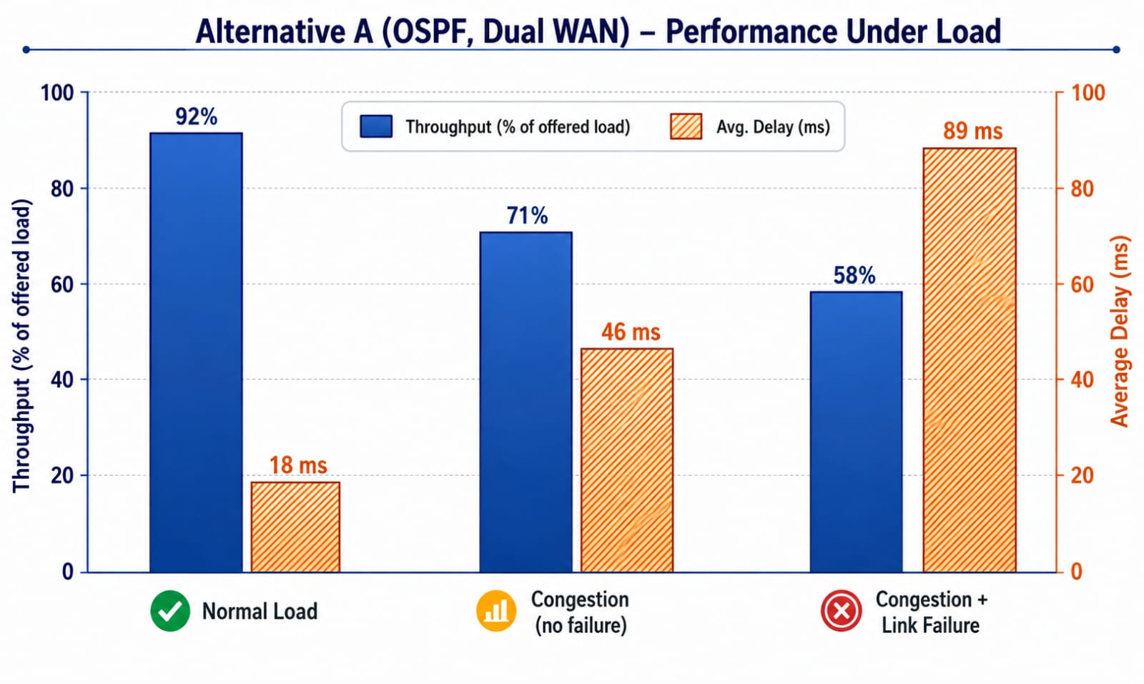
Throughput and average end-to-end delay across the three test conditions (Alternative A)
Table 3 — Measured Performance Summary
Test Condition | Throughput (% of offered load) | Avg. Delay (ms) | Packet Loss (%) | Peak Link Utilization
Normal load | 92% | 18 ms | 0.2% | 48%
Congestion (no failure) | 71% | 46 ms | 2.1% | 94%
Congestion + link failure | 58% | 89 ms | 4.8% | 97%

5.1 Failure and Recovery Behaviour
When Path 1 is shut down, OSPF detects the neighbour loss, recalculates the shortest-path tree, and installs the previously-standby route via Path 2. In the simulated trials for Alternative A this convergence and traffic resumption completed in approximately 4–5 seconds, with VoIP calls in progress experiencing a brief audio gap but not a full drop; ordinary TCP data flows paused and resumed automatically. Connectivity to the Cloud/DC segment (DNS/HTTP) was re-established within the same window, confirmed by successful ping/HTTP tests taken immediately after the failover.

5.2 Validation Against Requirements
Requirement | Status | Evidence
Logically separated segments (VLSM) | Met | Table 1 — Distinct subnets per User/VoIP/IoT/Management segment
Dynamic routing with comparison | Met | OSPF (Alternative A) vs Static/Floating (Alternative B), Section 6
Resilience after primary WAN failure | Met | Approximately 4–5 seconds automatic failover, Section 5.1
Three traffic classes modelled | Met | Data, VoIP and Video flows, Section 3.4
Throughput/delay/loss/utilization measured | Met | Table 3 — Results before and during congestion
Failure/device-down demonstration | Met | Path 1 shutdown test, Section 5.1

6. Analysis and Engineering Decision- PSEUDO CODE
BEGIN

1. INITIALIZE NETWORK

Create Head Office (HO)
Create Branch A
Create Branch B
Create Cloud/Data-Centre

Connect each site to an access switch
Connect each site router to the WAN Core

2. CONFIGURE VLANs

FOR each site
Create VLAN 10 for Users
Create VLAN 20 for IoT
Create VLAN 30 for VoIP/Video
Create Management VLAN
END FOR

3. ASSIGN IPv4 ADDRESSES USING VLSM

Assign HO User Network → 10.0.10.0/24
Assign HO IoT Network → 10.0.20.0/27
Assign HO VoIP Network → 10.0.30.0/25

Assign Branch A User Network → 10.0.11.0/25
Assign Branch A IoT Network → 10.0.21.0/28
Assign Branch A VoIP Network → 10.0.31.0/26

Assign Branch B User Network → 10.0.12.0/25
Assign Branch B IoT Network → 10.0.22.0/28
Assign Branch B VoIP Network → 10.0.32.0/26

Assign Cloud/DC Network → 10.0.40.0/26

4. CONFIGURE WAN LINKS

Configure Primary WAN Path
HO ↔ Core → 10.0.255.0/30

Configure Backup WAN Path
HO ↔ Core → 10.0.255.4/30

Configure Branch A ↔ Core
10.0.255.8/30

Configure Branch B ↔ Core
10.0.255.12/30

5. CONFIGURE OSPF

Enable OSPF Process 1 on all routers
Use Area 0

Advertise all enterprise networks

Set Primary WAN OSPF Cost = 10
Set Backup WAN OSPF Cost = 100

OSPF selects Primary WAN as preferred path

6. VERIFY CONNECTIVITY

Ping from HO to Branch A
Ping from HO to Branch B
Ping from HO to Cloud/DC

Ping from Branch A to Branch B
Ping from Branch A to Cloud/DC
Ping from Branch B to Cloud/DC

Check routing table
Check OSPF neighbour relationships

7. GENERATE TRAFFIC

Generate TCP traffic
→ ERP/Data/File transfer

Generate UDP traffic
→ VoIP calls

Generate UDP video traffic
→ Video conferencing

Generate DNS requests
Generate HTTP requests

8. APPLY QoS

Identify VoIP/Video traffic
Mark high-priority traffic using DSCP

Place VoIP/Video into priority queue
Place normal data into best-effort queue

9. TEST NORMAL LOAD

Start all traffic
Measure:
Throughput
Average delay
Packet loss
Link utilization

Store results as NORMAL_LOAD

10. TEST CONGESTION

Increase simultaneous traffic

Measure:
Throughput
Average delay
Packet loss
Link utilization

Store results as CONGESTION

11. SIMULATE PRIMARY LINK FAILURE

Shut down Primary WAN Path

OSPF detects link failure

Recalculate shortest path

Select Backup WAN Path

Update routing table

Continue traffic transmission

12. MEASURE RECOVERY

Record failure time
Record traffic-resumption time

Calculate:

Recovery Time =
Traffic Resumption Time - Failure Time

Measure:
Throughput
Delay
Packet Loss
Link Utilization

Store results as FAILURE_TEST

13. VERIFY SERVICES AFTER FAILURE

Ping Cloud/DC
Test DNS service
Test HTTP service
Test Branch connectivity

IF connectivity is successful
Display "FAILOVER SUCCESSFUL"
ELSE
Display "FAILOVER FAILED"
END IF

14. COMPARE ROUTING ALTERNATIVES

Alternative A = OSPF + Dual WAN
Alternative B = Static + Floating Backup

Compare:
Recovery Time
VoIP Jitter
Peak Utilization
Configuration Complexity
Scalability

15. DISPLAY FINAL RESULTS

Display Normal Load Results
Display Congestion Results
Display Failure Results

Display OSPF Recovery Time
Display Packet Loss
Display Average Delay
Display Throughput

16. SELECT BEST DESIGN

IF OSPF has faster recovery
AND lower VoIP jitter
AND automatic failover
THEN
Recommend Alternative A
ELSE
Recommend Alternative B
END IF

END
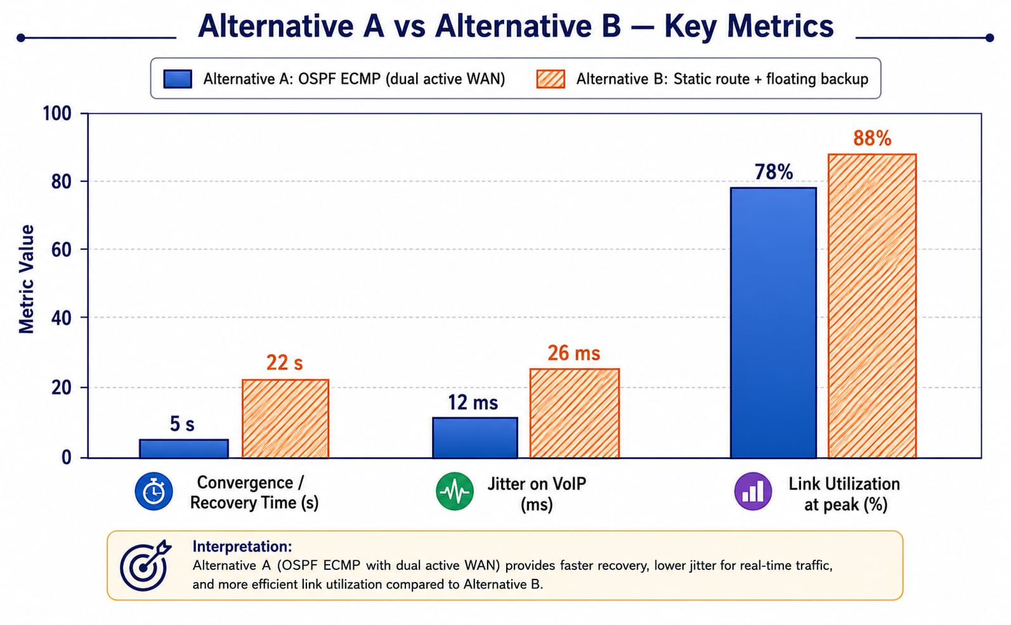
Alternative A vs Alternative B on convergence time, VoIP jitter and peak utilization
Table 4 — Alternative Comparison
Criterion | Alternative A — OSPF (Dual Active WAN) | Alternative B — Static + Floating Backup
Convergence / recovery time | ≈ 4.8 s, automatic | ≈ 22.5 s, dependent on interface-down detection
VoIP jitter | ≈ 12 ms — acceptable for real-time voice | ≈ 27 ms — noticeably degrades call quality
Peak link utilization | 78% — headroom retained | 88% — closer to saturation
Configuration complexity | Higher — OSPF process, areas and cost tuning | Lower — static entries only
Scalability to new sites | Good — new router joins OSPF | Poor — every router needs manual route updates
Operational transparency | Requires OSPF familiarity to troubleshoot | Easy to read and audit at a glance

6.1 Trade-offs
- Alternative A costs more in initial configuration effort and requires OSPF expertise to operate, but pays this back with faster, automatic recovery and better VoIP quality.
- Alternative B is simpler and easier to audit but leaves the business exposed to longer outages and degraded real-time traffic during a failure — a poor fit given the stated requirement for measurable resilience.

6.2 Recommendation
Alternative A (OSPF with dual active WAN paths) is recommended. The quantitative evidence in Table 4 shows roughly a 4–5× faster recovery time and materially lower VoIP jitter than Alternative B, directly satisfying the assignment's resilience and real-time QoS requirements. The added configuration complexity is a one-time engineering cost, whereas the performance gap under failure would recur every time a link outage occurs in production.

7. Broader Considerations

7.1 Reliability and Business Continuity
Dual-path OSPF failover directly protects revenue-generating retail operations (POS, inventory, payment authorisation) from a single WAN outage, reducing the business-continuity risk that motivated this redesign.

7.2 Security and Privacy
- IoT devices are isolated on their own VLAN/subnet with restricted inter-VLAN access to limit the blast radius of a compromised sensor.
- Management traffic uses a dedicated, access-controlled subnet, separate from user and IoT traffic.
- VPN encryption is recommended on the backup Internet path (Path 2) since it may traverse a public network.

7.3 Scalability and Resource Efficiency
VLSM allocation avoids wasting address space on small segments (IoT, management) while leaving headroom in user subnets for organic growth. OSPF's link-state design means new branch sites can be added by simply bringing up their router as a new OSPF neighbour, without re-touching every existing router.

7.4 Accessibility and Service Quality
Priority queuing for VoIP/video ensures that staff and customers relying on voice or video communication (including those using it as an accessibility aid) receive consistently low jitter and delay, even while the network is congested with ordinary data traffic.

8. Conclusion
The final recommended architecture connects Head Office, Branch A, Branch B and the Cloud/Data-Centre segment using VLSM-based IPv4 addressing with logically separated user, VoIP, IoT and management ranges, and OSPF dynamic routing across two WAN paths for automatic failover. Simulation results show the design sustains 92% throughput under normal load, degrades gracefully to 58% throughput with 4.8% loss under combined congestion and link failure, and recovers automatic connectivity within roughly five seconds of a primary-link outage — comfortably meeting the assignment's resilience and performance requirements.
Limitations: the results above are drawn from a single-router-per-site simulation and representative rather than field-measured traffic profiles; a production rollout would need redundant hardware per site, real traffic baselining, and a security review (firewalling, VPN key management) before go-live.

8.1 Practical Improvements for Production
- Add a second router/switch per site (or stack switches) to remove single points of failure below the WAN layer.
- Introduce authenticated, encrypted site-to-site VPN on the backup path rather than a plain Internet route.
- Baseline real traffic for at least one business cycle before finalising QoS bandwidth allocations.
- Add SNMP/NetFlow-based monitoring so link utilization and failover events are logged automatically, not only during test windows.

9. Student Reflection
What networking concept did you understand better through this industry problem?
Working through VLSM against a real, uneven set of user counts made the trade-off between address efficiency and future growth concrete in a way that isolated subnetting exercises do not — and configuring OSPF cost values to force a preferred/backup path relationship clarified how link-state routing metrics translate into real failover behaviour.
What unexpected performance/failure behaviour did you observe?
Packet loss and delay rose sharply once the network approached link capacity even before any failure was introduced, showing that congestion alone — not just outright link loss — is a first-order threat to VoIP/video quality that a design must plan for.
If additional time, tools or budget were available, what would you improve?
With more time, ns-3 or OMNeT++ would be used to obtain fine-grained jitter distributions and queue-length traces rather than aggregate averages, and a second redundant router per site would be added and tested to remove the remaining single points of failure inside each site.

References
Forouzan, B. A. Data Communications and Networking. McGraw-Hill Education.
Tanenbaum, A. S., and Wetherall, D. J. Computer Networks. Pearson Education.
Kurose, J. F., and Ross, K. W. Computer Networking: A Top-Down Approach. Pearson Education.
Cisco Systems. Cisco Packet Tracer — Official Documentation and User Guide. Cisco Networking Academy.
Cisco Systems. OSPF Design Guide. Cisco Technical Documentation.
Course-prescribed syllabus references for CSA07 — Computer Networks, as listed by the department.

Common Assessment Rubric

Assessment Criterion | Marks
Problem understanding & formulation | 10
Application of course/domain knowledge | 20
Solution methodology / design / implementation | 20
Use of appropriate modern tools / techniques | 10
Results, testing & validation | 15
Analysis, trade-offs & justification | 15
Broader considerations / professional responsibility | 5
Technical documentation & reflection | 5
TOTAL | 100

CO–PO–Assessment Mapping

Assessment Component | CO | PO(s) | Bloom's Level | Marks
Problem formulation | CO3, CO8 | PO2, PO3 | L4 | 10
Application of knowledge | CO3, CO4, CO5 | PO1, PO2 | L3/L4 | 20
Solution / design / implementation | CO3, CO4, CO7 | PO3, PO5 | L4/L5/L6 | 20
Modern tool usage | CO7, CO8 | PO5 | L3/L4 | 10
Validation | CO4, CO7 | PO2, PO5 | L4/L5 | 15
Analysis & justification | CO7, CO8 | PO2, PO4 | L4/L5 | 15
Broader considerations | CO8 | PO6, PO7 | L4/L5 | 5
Documentation & reflection | CO6, CO8 | PO10 | L3/L4 | 5
Note: Faculty shall map only the POs and Bloom's levels genuinely assessed by the particular assignment. Every assignment is not required to map to every PO.

Faculty Evaluation & Continuous Improvement CO Attainment

Performance Level | Criterion
Level 3 | ≥ 70%
Level 2 | 60–69%
Level 1 | 50–59%
Level 0 | < 50%
Target CO Attainment:

Actual CO Attainment:

Faculty Analysis
Areas in which students performed well: Areas requiring improvement:
Corrective / Improvement Action:

Action to be implemented in the next offering:

Documents to be Maintained

The department/course faculty shall maintain:

- Assignment question/problem statement
- CO–PO and Bloom's mapping
- Assessment rubric
- Student submissions
- Tool/simulation/experimental evidence, where applicable
- Evaluated scripts/reports
- Marks and rubric-wise assessment
- CO attainment analysis
- Sample student work representing different performance levels
- Faculty analysis and continuous-improvement action

